A Level Psychology
Transition Pack
What does Pavlov use to wash his hair?
Classical conditioner!

Psychology: the scientific study of the human mind and behaviour

You are required to complete ALL of the activities in this transition pack for submission in the first week of the new academic year. The A Level in Psychology is a fun, embracing yet challenging qualification. It will develop your thinking skills and vastly expand your knowledge of human behaviour. There will be nine taught hours per fortnight. It is then expected that students do three to five hours per week of homework and independent study at home and during their approximately 20 fortnightly free periods.

This is a detailed and comprehensive assignment that you have been given. Do not rush it. We advise that you complete different parts of the transition pack at different points in the Summer holiday, rather than leaving it all until the final week of your break. You should expect to spend longer on these tasks than any homework you have completed before. A Level Psychology will be a significant step up from the work you have completed in Year 11.
Task One – Approaches in Psychology
There are some core approaches to Psychology that you need to know for your A level – they are different ways of explaining human behaviours. Some of these are listed below: your job is to do some research on them using the internet (Wikipedia, while sometimes untrustworthy, is very good for this! There are also plenty of great videos on YouTube you can watch). You should find out: what does this word mean? How might it explain human behaviour? Identify one key researcher from this area – and why are they famous?
The Behaviourist Approach
The Social Learning Theory Approach
The Cognitive Approach
The Biological Approach
Optional extension: The Psychodynamic Approach & Humanistic Approach
Task Two – Psychological History
You need to create an A4 Psychological History timeline. On your timeline you should include a number of features such as the ones below (but not necessarily ONLY these). To make a high quality timeline, you will need to do some additional research into what each of the events actually refers to – and why it might have been important to the development of Psychology.
The Curious Case of Phineas Gage, Wilhelm Wundt’s Psychology Lab, foundation of the American Psychological Association, Sigmund Freud publishes “The Interpretation of Dreams”, Pavlov’s Dog Studies are published, Carl Rogers publishes “Counselling and Psychotherapy”, the first use of a brain scan in Psychological research.
This will be the focus of the first topic we will study next year. A great link for this task is https://allpsych.com/timeline/.
Task Three – Psychology Today
Psychology is still a developing subject, with new research and information being revealed every single day. As keen young Psychologists, you need to keep abreast of new information. Twitter is seen by some to be the future of social science – it is used by researchers, academics and other social scientists alike to share news and information as well as discuss issues. I would advise that you create yourselves Twitter accounts as soon as possible and follow the below users for information and news:
@PsychToday (Psychology Today magazine)
@tutor2uPsych (Tutor2U’s Psychology feed)
@ResearchDigest (the British Psychological Society’s Research feed)
@Psychmag (The Psychologist magazine)
Your second task is to keep an eye on these Twitter accounts (as well as wider sources – the news and shows on TV, newspapers and others – there are loads of fantastic movies and documentaries that you can watch for Psychology!) over the Summer holidays and make a note of any particularly interesting news that is relevant to Psychology.
Task Four – Researching Psychological Disorders
Your final task is to explore some psychology in the real world by looking at two of the following disorders. For each, you should create a short factfile: what is the disorder? What are the psychological causes? How do psychologists treat this disorder? Choose two to complete, but if you like you can complete more! The disorders are:
It is a requirement of the course that by the end of the second week in September you have purchased the compulsory Year 1 textbook. There are a number of available textbooks for this course – it is very important that the correct one is purchased. An image has been attached below.
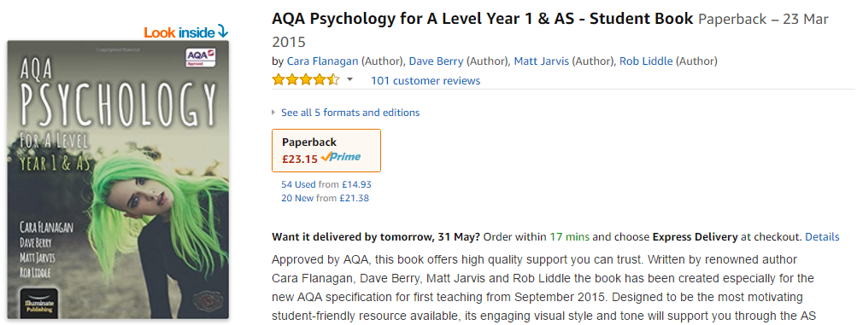
Depression
Obsessive-Compulsive Disorder (OCD)
Dissociative Identity Disorder (DID)
Anorexia Nervosa
Schizophrenia
Agoraphobia
Antisocial Personality Disorder (APD)
Obesity

If you have any further questions while you are enjoying your Summer holiday, my email address can be found below
Mr Hill
thill@sawtryva.org

