IT Post-16 Transition work
All resources can be found here: https://en-gb.padlet.com/EAnakwa/IT_Transition
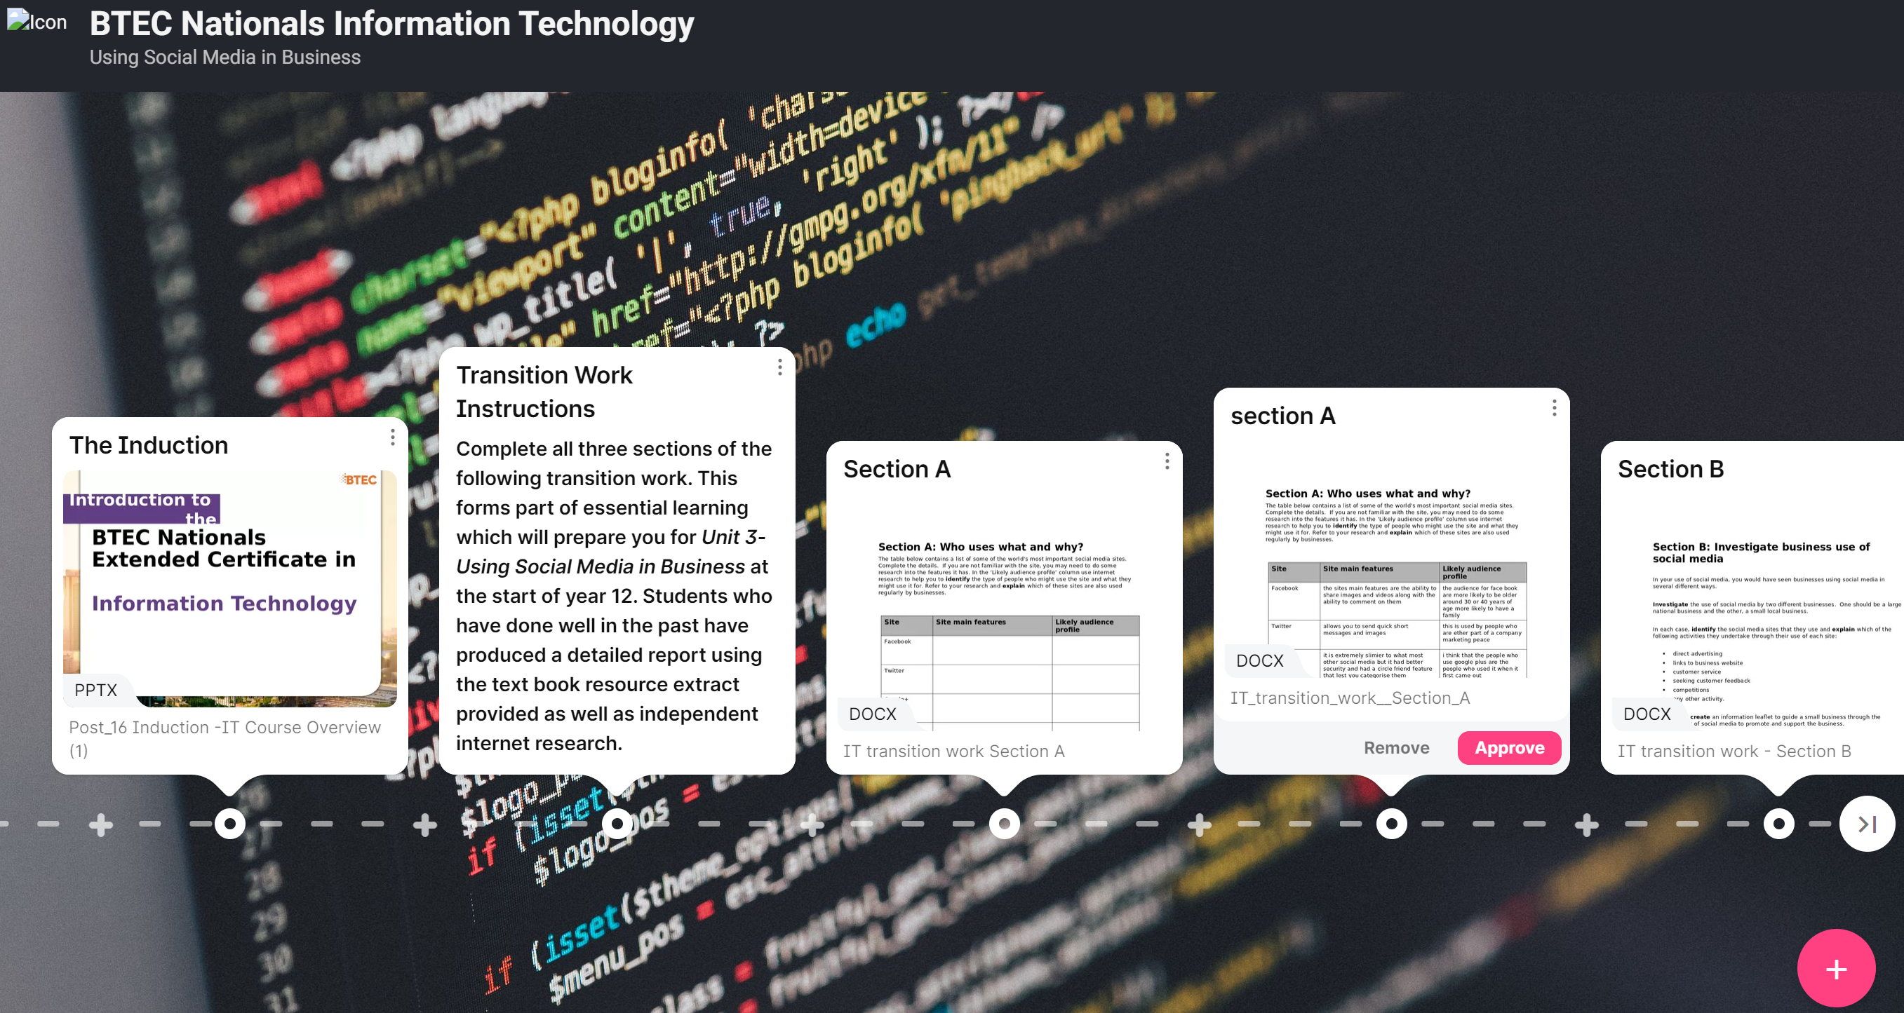
You must watch the induction presentation and follow the transition work instructions to complete the activities set in all 3 sections as well as the consolidation work. Navigate to the right to find all the consolidation work and resources
All work must the completed and submitted by the deadline set by the sixth form team.
If you have any queries regarding the transition work contact. Mr Anakwa at eric.anakwa@kinsgthorpecollege.org.uk

