Firstly, please click here – or below on the image – to view an online introductory guide to the LIBF (London Institute of Banking and Finance https://www.libf.ac.uk/study/financial-education/qualifications/diploma-in-financial-studies-(dipfs) ) Level 3 Financial Studies course that we offer as a post-16 subject option, equivalent to 1 A Level, at Kingsthorpe College.
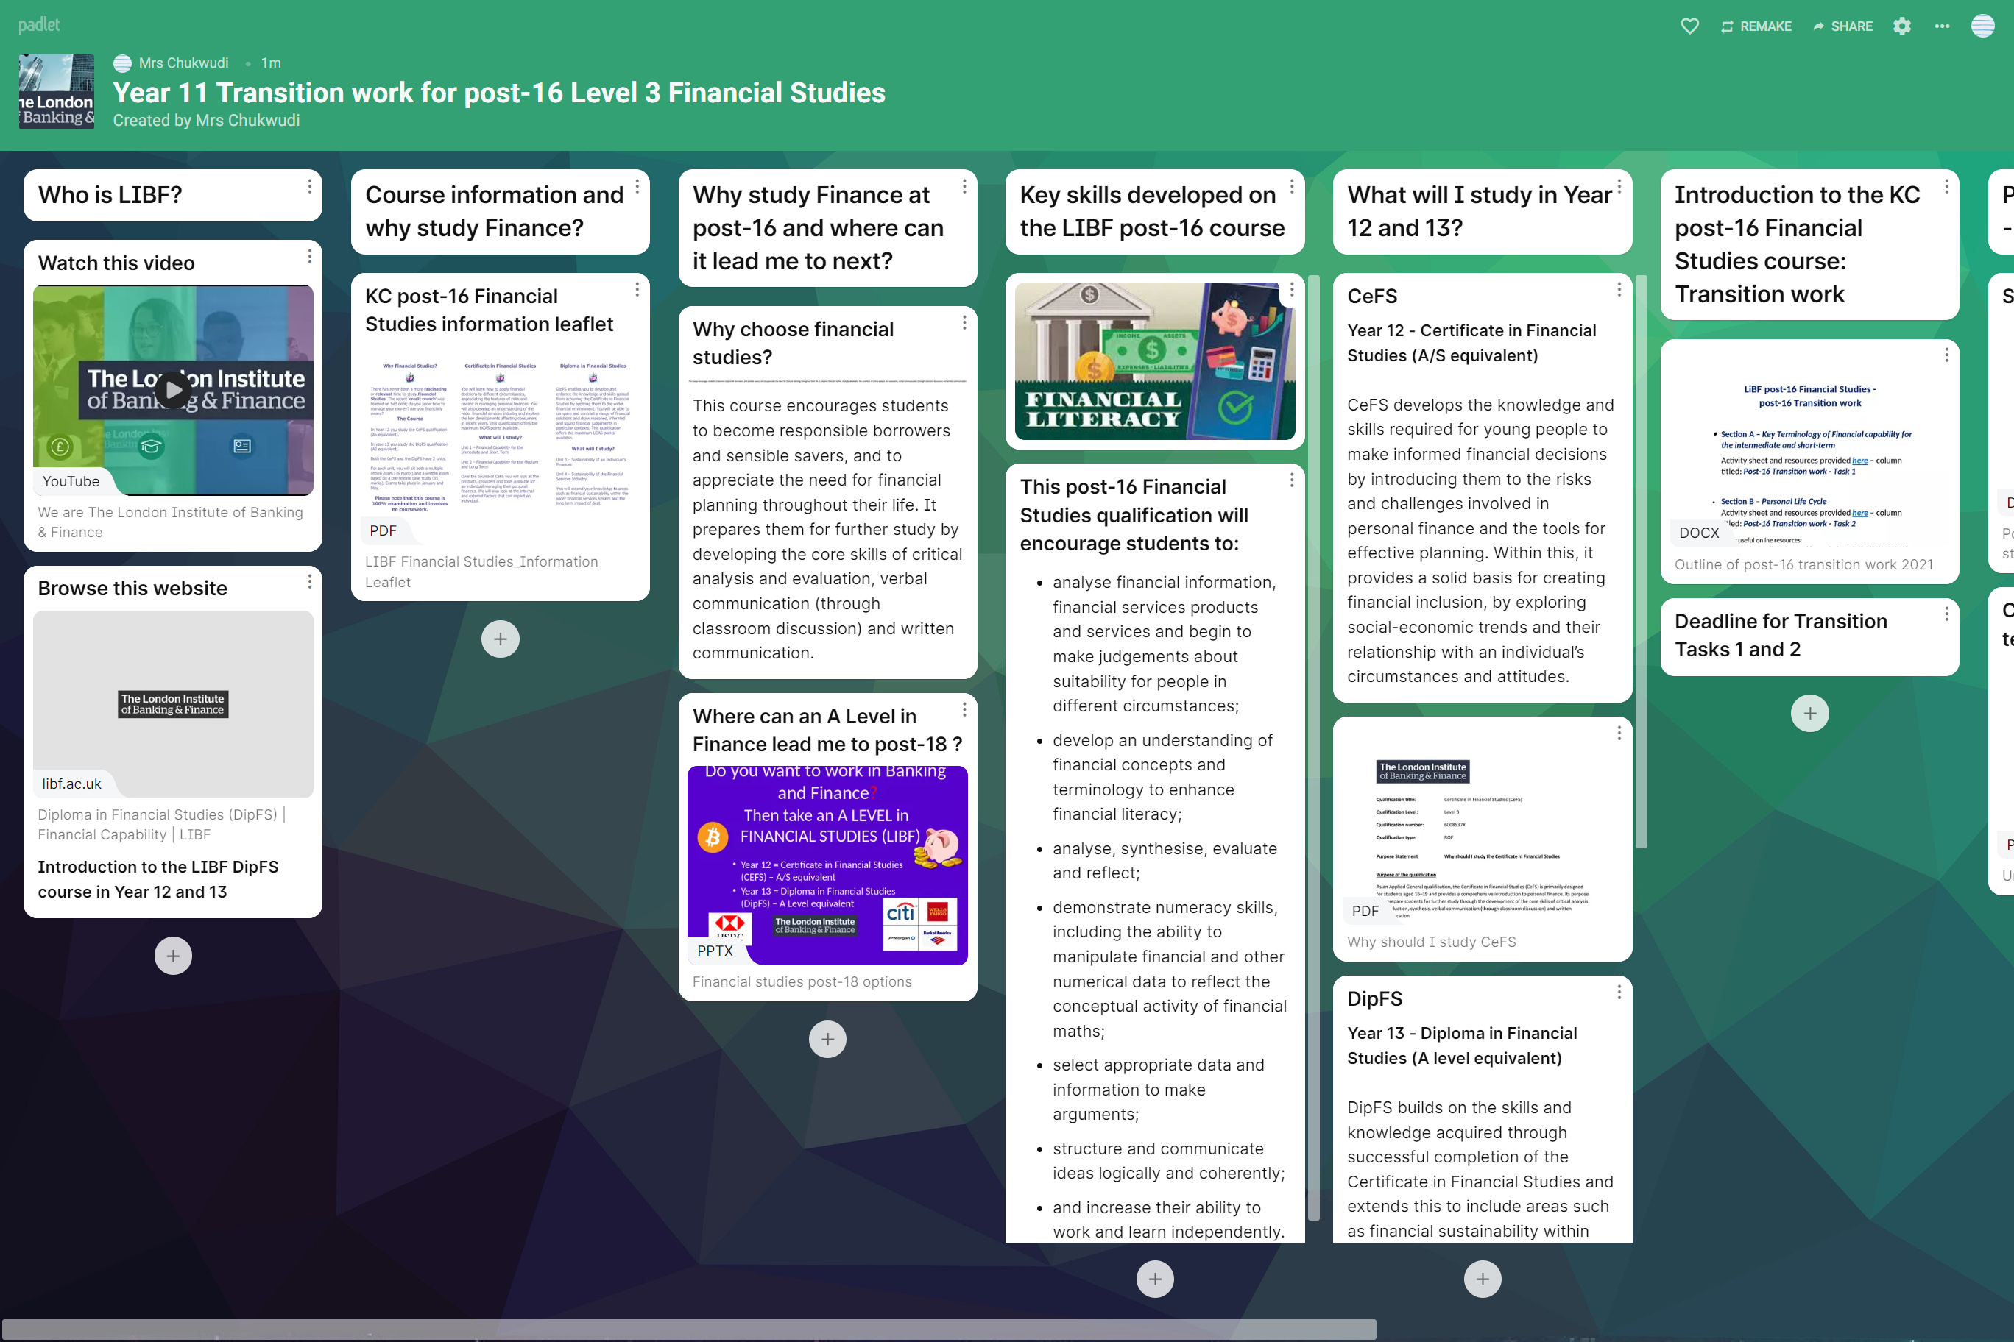
- Section A – Key Terminology of Financial capability for the intermediate and short-term
Activity sheet and resources provided here – scroll to the right and view column titled: Post-16 Transition work - Task 1

- Section B – Personal Life Cycle
Activity sheet and resources provided here – scroll to the right and view column titled: Post-16 Transition work - Task 2
Other useful online resources:
- https://investoracademy.org/how-you-should-live-the-5-financial-stages-of-life/
- https://toughnickel.com/personal-finance/The-Life-Cycle-of-Financial-Planning
- https://www.youtube.com/watch?v=bZ9uvIgsnUA
Contact information:
Any questions about the post-16 Financial Studies transition work please contact:
Mrs Chukwudi – julie.chukwudi@kingsthorpecollege.org.uk
For any technical issues please contact: Home.Learning@kingsthorpecollege.org.uk

