
Name: _________________________
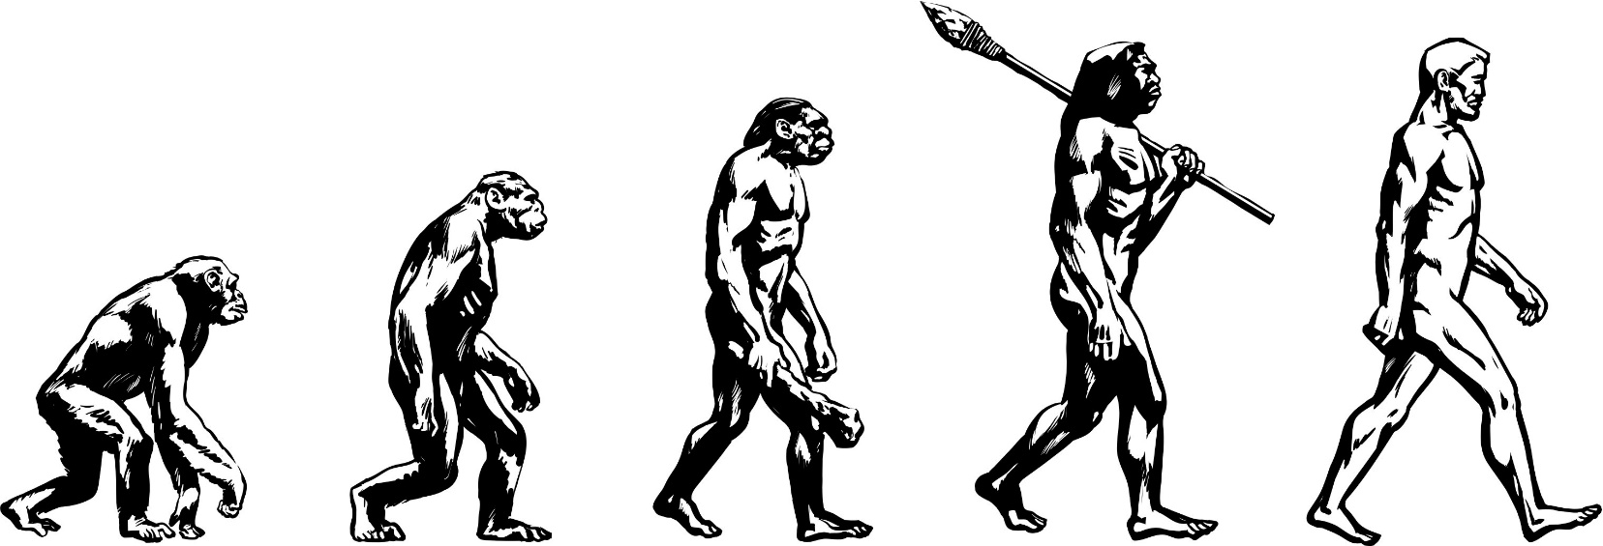
AQA A-level Biology
Transition Booklet
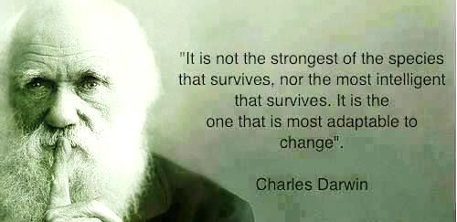

Contents
Introduction…………………………………………………….……3
Resources………………………………………….…………………4
Course outline………….……………………………………………7
Structure of lessons and building helpful routines…………………..9
Wider reading………………………………………………..……10

TRANSIITON TASKS to be completed for September
Task 1: Cells- Types of cell ………………………………...…..12-13
Task 2: Cells - Microscopes……………………………………..…14-15
Task 3: Cells -Mitosis………………………………………………….… 16
Task 4: Cells- Key terms……………………………...……………… . 17
Task 5: Biological Molecules- Food Groups (introduction).……… 18
Task 6: Biological Molecules- Food Groups ……………..……..19-20
Task 7: Biological Molecules – Enzymes …………………….…21-22
Task 8: Biological Molecules- Key terms…… ……………………… 23
Task 9: Date and How Science Works………………………...….. 24-26
Task 10: Research project…………………………………………27

Alternative optional extras……………………………………28-29

Introduction
Thank you for choosing to study A-level Biology as one of your A-level options. As keen biologists ourselves, we are excited to welcome you on to our course and begin preparing you for the challenging and yet rewarding years ahead.

Biology is the study of living things, but not just animals and plants. You’ll also learn about the molecules that make living things work, the cells that they’re made from, the systems within plants and animals, and the interconnections between organisms.
Biology is different from physics and chemistry, in that living things don’t always do what you expect them to do. You can’t test one organism and assume all the rest will be the same, so you’ll learn about the statistical analysis behind making claims.

Biologists are at the forefront of many world issues and hold incredibly privileged positions such as:
- Medical researcher
- Genetic councillor
- Drug developer
- Bioengineer
- Veterinary scientist
- Physiotherapist
- Pharmacologist
- Marine Biologist
Plus supporting several other professions

Some students find the transition from GCSE to A-level Biology exceedingly difficult. To help make this transition smoother and to give you the best possible start, we have prepared this booklet for you.

It is important that you read through this booklet and then complete all the questions. If you require more space, then you can use lined paper. Many of the topics are GCSE topics which you should have already covered. You will need secure knowledge of these topics before you start the course in September. In addition to this there are several questions that require you to research a topic so that you become familiar with new vocabulary and concepts.

Resources
To help you complete this booklet, and over the next two years, the following resources may be useful:
- Head Start to AS Biology Published by CGP
- https://revisionscience.com/a2-level-level-revision/biology-level-revision
- https://studywise.co.uk/a-level-revision/biology/
- The student room thestudentroom.co.uk
Join the A-level Biology forums and share thoughts and ideas with other students if you’re stuck with your homework. Just be very careful not to share any details about your assessments, there are serious consequences if you’re caught cheating.
- Magazines: can help you put the biology you’re learning in context. Particularly accessible ones include
Focus
New Scientist
Big Picture
Philip Allan updates
- TED talks
- Social Media:
Facebook
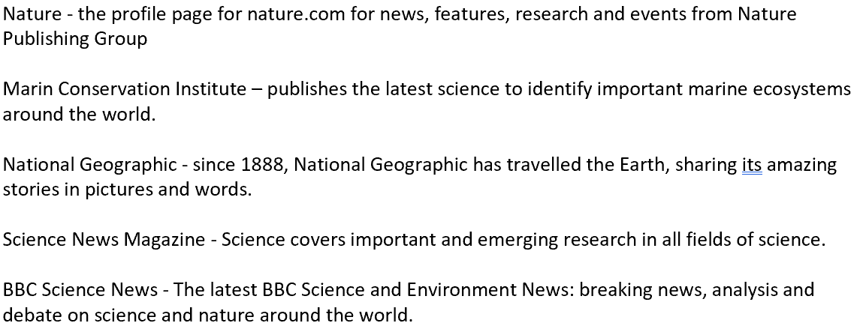

TikTok:
Miss Estruch - https://www.tiktok.com/link/v2?aid=1988&lang=en&scene=bio_url&target=https%3A%2F%2Fmissestruchbiology.mykajabi.com%2Flink-in-bio%3Ffbclid%3DPAAaaFdY3mWb8c7ozX91xyExDzRxE7TwayF6Op9EnvpeV5eNnyVhjR0deUIwo
Primrose Kitten Academy - https://www.tiktok.com/link/v2?aid=1988&lang=en&scene=bio_url&target=https%3A%2F%2Fwww.primrosekitten.com%2Fpages%2Flinks

X (formally Twitter)
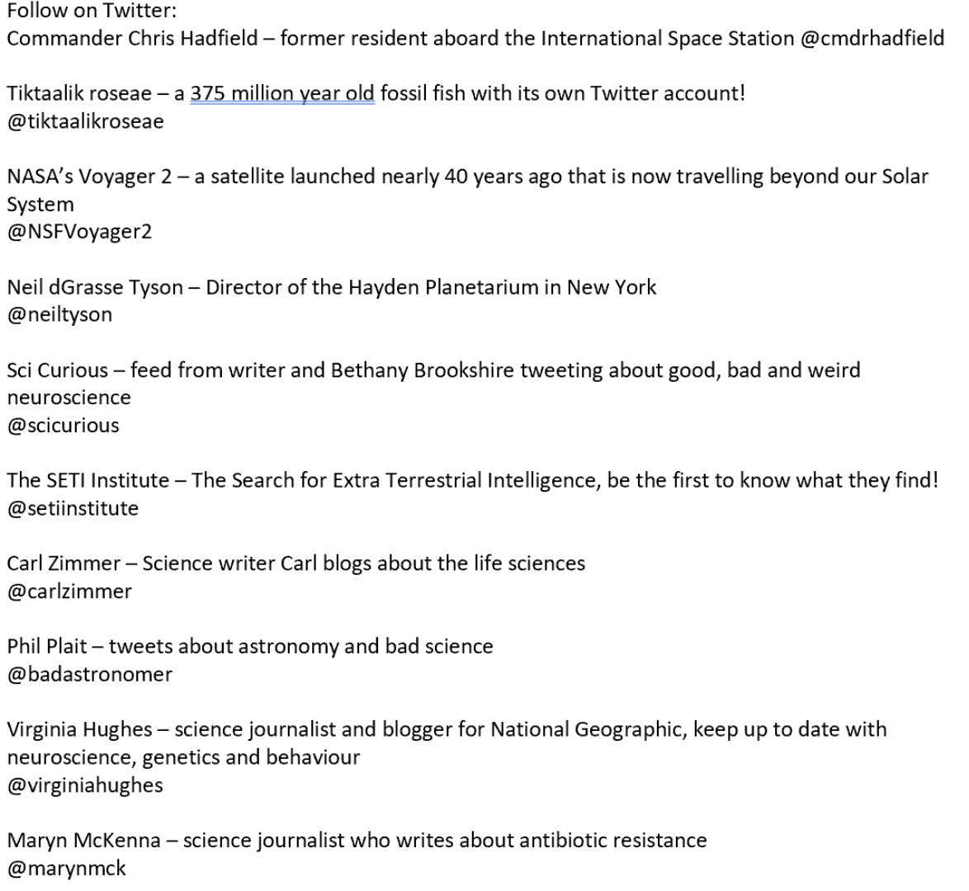
- Physics and Maths Tutor https://www.physicsandmathstutor.com/
Find past papers and mark schemes grouped by topic as well as notes and revision flashcards
- Biology Websites:
rsb.org.uk (Royal Society of Biology)
“A single unified voice for biology”. They work with everyone from government policy makers to students, as well as universities and researchers studying biology. Their website includes a dedicated student section.
http://learn.genetics.utah.edu/ - Learn Genetics from Utah University
It is pitched at an appropriate level for you and has lots of interactive resources to explore, everything from why some people can taste bitter berries to how we clone mice or make glow in the dark jelly fish.
https://www.zsl.org/conservation
Many Zoos have great websites, especially London Zoo. Read about some of the case studies on conservation, such as the Giant Pangolin, the only mammal with scales.
http://sciencecourseware.org/vcise/drosophila/
At GCSE you learnt how genetic diseases are inherited. In this virtual fly lab you get to breed fruit flies to investigate how different features are passed on.
DNA from the beginning is full of interactive animations that tell the story of DNA from its discovery through to advanced year 13 concepts.
http://www.dnaftb.org/
Not technically a website, but a video you definitely want to watch. One of the first topics you will learn about is the amazing structure of the cell. This BBC film shows the fascinating workings of a cell… a touch more detailed than the “fried egg” model you might have seen.
http://www.dailymotion.com/video/xzh0kb_the-hidden-life-of-the-cell_shortfilms
If this link expires – google “BBC hidden life of the cell”

Course outline
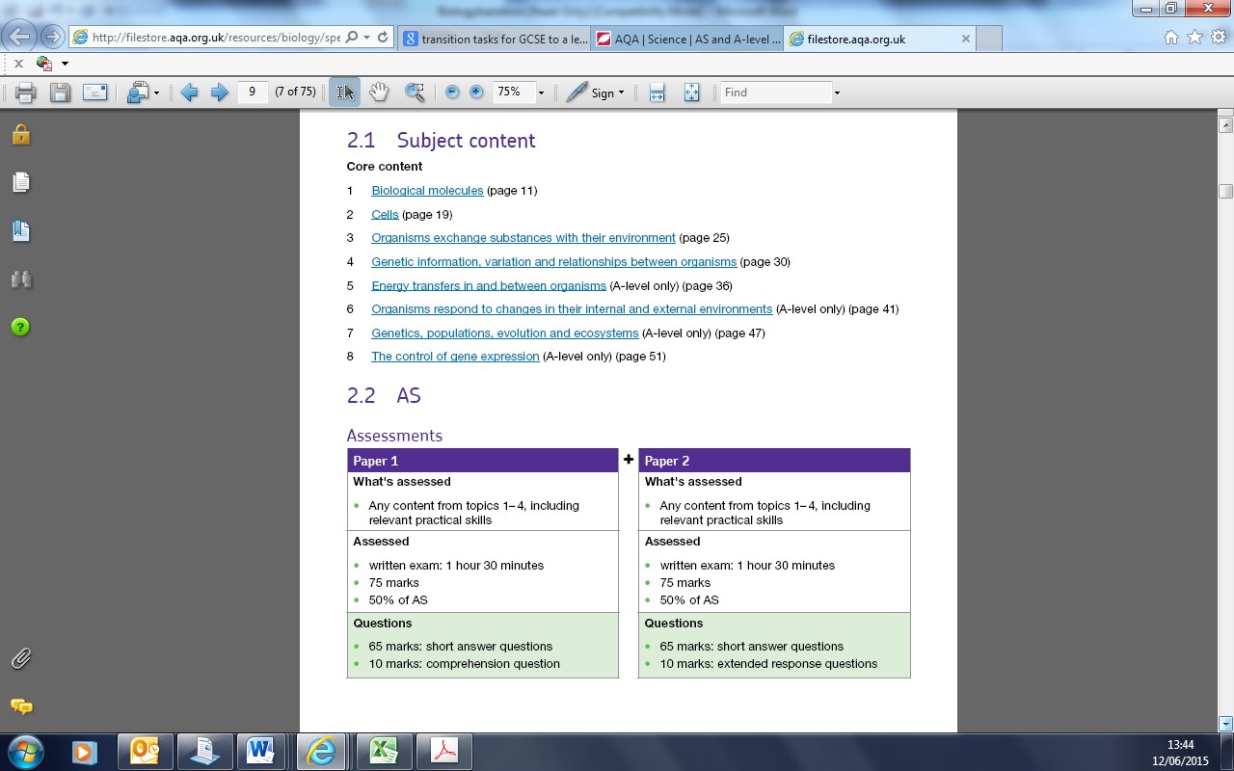
The study units outlined in the specification:
Assessment
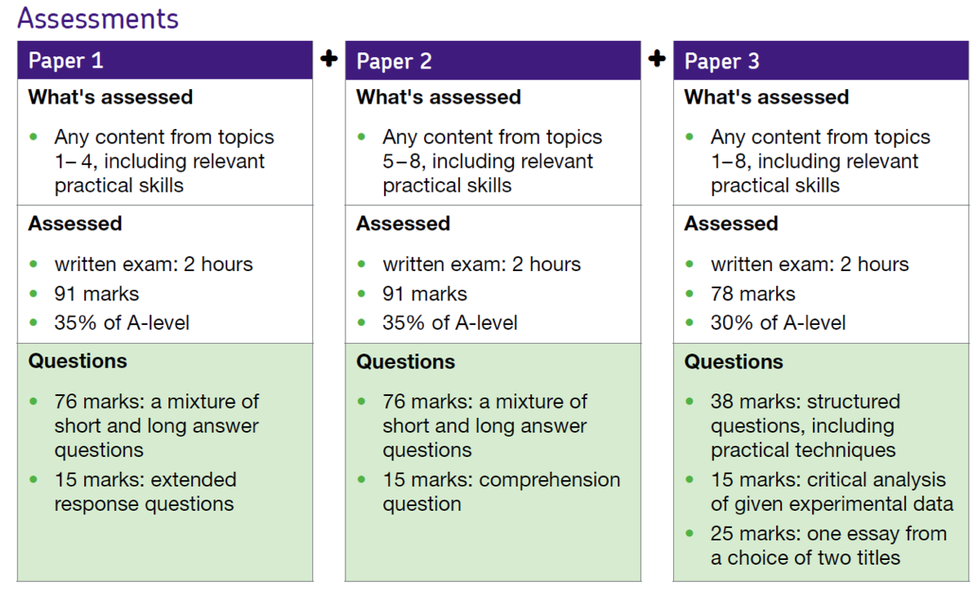

Maths expectations
10% of the marks across the three A Level papers comes form maths skills at GCSE Higher tier level, plus any additional maths skills explicitly taught across the two years. This includes statistical testing and interpretation.
Additional support can be found at AQA | Maths skills briefings for A-level sciences
Practical Course
Over the 2 years you will be required to carry out 12 practicals. These will give you a practical skills in biology accreditation and will also be assessed throughout your exams. Sometimes you will be asked to carry out research and present your findings as a lab report.
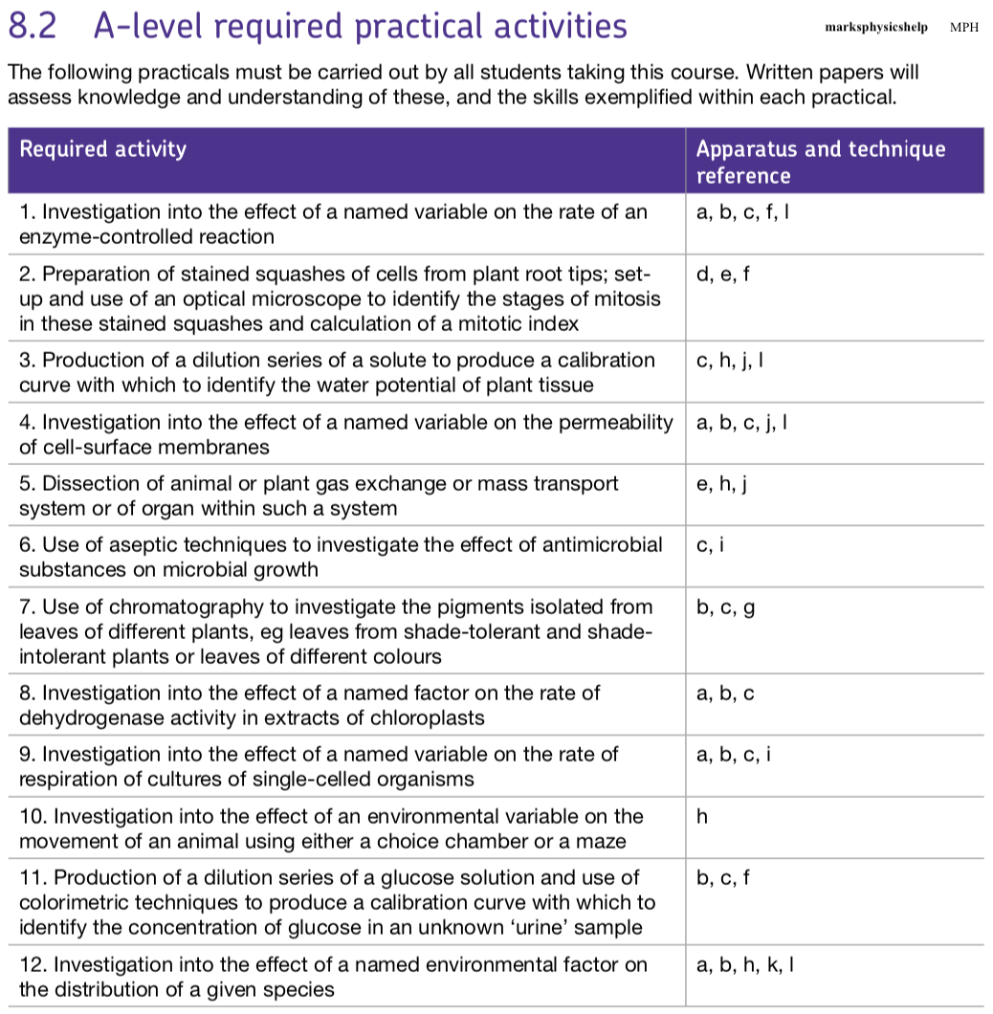

Don’t forget everything you learnt at GCSE! Now your KS4 exams are done, it can be tempting to want to leave them behind you, however gaps in your GCSE knowledge can make building on this content at A Level even harder.
In year 12 alone, we build upon:
Cells Transport of substances Enzymes
Food tests Digestion Breathing
The heart Transport in plants Infection and response
Cell cycle Meiosis Protein synthesis
Structure of lessons and building helpful routines
There will be 9-10 timetables lessons a fortnight. You will be required to actively participate in lessons by asking and answering questions, contributing and sharing ideas.
To be successful, it is recommended that you spend around 4 hours per week outside of lessons consolidating your learning. Examples of activities you can do independently include:
Weekly routine:
- writing up your notes, going back through the PowerPoints and adding in details that you didn’t have time to in the lesson. Use additional sources to add into lesson notes too or read around the subject using the additional sources listed in this booklet
- Organise your folder (by teacher and by chapter usually works well) to keep on top of your notes as you go – don’t leave it until it comes to the time to revise!
- Before each lesson, make sure you’ve read ahead a sub-chapter or two in the textbook. Learn the definitions of any words in orange in the chapter textbook and take the opportunity to recap any GCSE knowledge that you may have forgotten ready to build upon in the lesson. Have an initial go at the summary questions at the end of the sub-chapter. This way, you will arrive at the lesson well-prepared and hitting the ground running.
- Make sure you have a go at all homework tasks set. Work with a peer and/or ask for help from them when you need it.
- Do at least 1 hour (ideally 2-3 hours) of practice questions per week – e.g. past paper questions from the AQA website or from the Biology section of the Physics and Maths Tutor website. The end-of-chapter questions are good too (answers here - https://global.oup.com/education/content/secondary/series/aqa-a-level-sciences/aqa-a-level-sciences-student-book-answers/?region=uk). This spaced testing of previous work is a really effective way to learn, and you will find that things start to make sense (albeit sometimes several months after you first came across it!)
- Any queries you have from your work outside of lessons, work them through with a peer. If you’re both stuck, take the query to the next lesson.

Mock preparation:
- The definitions of all the key terms from the specification will be in the glossary at back of the book. Learn these by heart – this will free up brain space to get your head round some of the trickier concepts in the course.
- Making (and using!) flashcards is a great way to memorise information. There’s some really handy advice on what makes a good flashcard here - https://www.news24.com/life/archive/watch-how-to-study-using-flashcards-20160825), along with details of the Leitner system for using flashcards effectively.
- Use the Learning Objectives at the start of each sub-chapter (double-page spread) or spec points on the RAG sheet as a quiz. Quiz yourself, or, even better, get together with one of your friends and quiz each other. Go back over any objectives that you didn’t get by looking through the relevant chapter.
- Have a go at past papers from the websites listed above, and mark them using the mark scheme.

Developing exam technique:
- Learn the steps for answering different questions, for example, use the units to help you to work backwards in maths questions, make sure you’ve included specific key terminology in your answers as these appear every time, such as enzyme-substrate complex in questions focused on enzyme action, or the correct phrasing for statistics based questions.
- When you do practice questions, write down an explanation for yourself about how to answer the questions, based on what you did to get the answer, or how the mark scheme approached it. Any questions you struggled with, retry them 2 weeks later to see how much you have retained.
Wider Reading
To help provoke your love of Biology we have recommended a few books which will hopefully not only be interesting but allow you to acclimatise yourself to some of the more sophisticated biological language.
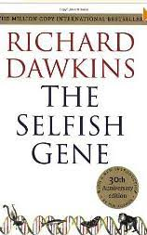

Dawkins coined the term "selfish gene" as a way of expressing the gene-centred view of evolution as opposed to the views focused on the organism and the group. From the gene-centred view follows that the more two individuals are genetically related, the more sense (at the level of the genes) it makes for them to behave selflessly with each other. Therefore the concept is especially good at explaining many forms of altruism, regardless of a common misuse of the term along the lines of a selfishness gene.

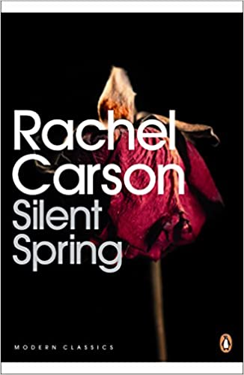

A book that can be attributed to the start of the modern environmentalist movement. Great for any budding ecologists out there.

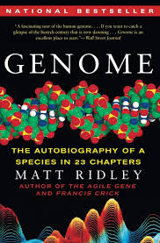

Each chapter in this seminal work focuses on 1 human chromosome detailing some fascinating genes or mutations that are present on each one. Several genetic disorders are covered in the book as well is explaining gene expression in various phenotypes such as hair colour.

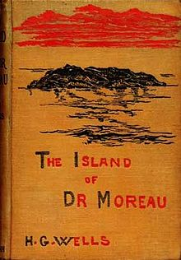
The Island of Doctor Moreau is an 1896 science fiction novel by English author H. G. Wells. The text of the novel is the narration of Edward Prendick, a shipwrecked man rescued by a passing boat who is left on the island home of Doctor Moreau, a mad scientist who creates human-like hybrid beings from animals via vivisection. The novel deals with a number of philosophical themes, including pain and cruelty, moral responsibility, human identity, and human interference with nature.



Studying Geography as well? This is a book by a great evolution writer. It discusses lots of fascinating stories about geology and evolution



Discover how glow in the dark fish are made and more great biotechnology breakthroughs.

TRANSITION TASKS
Cells - Types of Cell - For the following cells label the parts on the diagram and the define their functions.
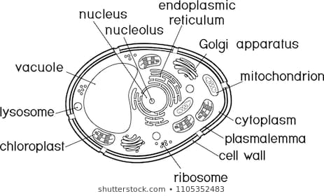
Eukaryotic:
+
Organelle | Function - (Include detail on structure)
Nucleus
Cytoplasm
Cell Wall
Chloroplast(s)
Vacuole
Ribosome(s)
Mitochondrion(s)
Plasma membrane(s)
Nucleolus
Golgi Apparatus
Lysosome
Smooth E.R.
Rough E.R.
Prokaryotic:
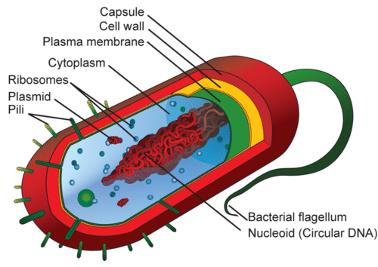

Organelle | Function
Plasmids
Nucleoid
Capsule
Pili
Flagellum

Organelle | Function
Capsid
Glycoprotein
Reverse Transcriptase
RNA
Envelope
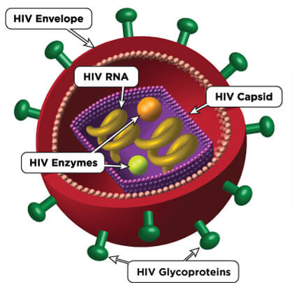
Virus:

Cells – Microscopes
For each microscope below draw/print/describe how it works and give their advantages and disadvantages:
Microscope | How it works | Advantages/Disadvantages
Optical |  | A
Optical |  | D
Scanning Electron Microscope |  | A
Scanning Electron Microscope |  | D
Transmission Electron Microscope |  | A
Transmission Electron Microscope |  | D

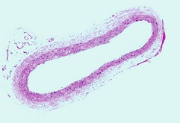
For each microscopic image, using an equation to calculate either magnification, real size or image size.
Calculate the magnification when 100µm has an image size of 10mm? Show your working.
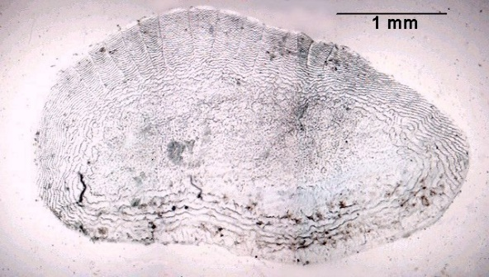
To view this cell an optical microscope was used at x400 magnification. Calculate its image size. Show your working.

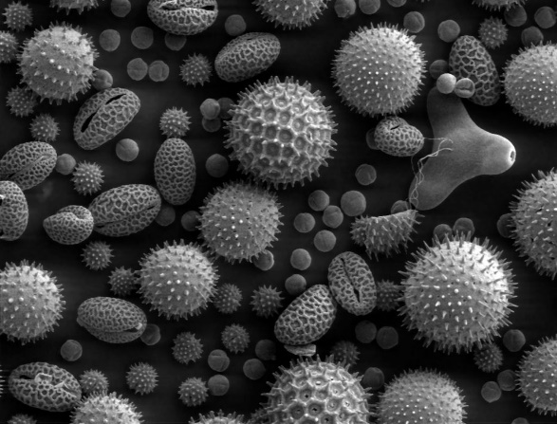
To view this cell an optical microscope was used at x2500 magnification. Calculate its actual size. Show your working.
Draw a scientific diagram of one of the cells above.

Cells- Mitosis
Mitosis is the process by which cells divide. It is split into 5 key steps. Complete the table list these 5 steps, giving a diagram and a description of what is happening with the organelles involved.
Mitosis Stage | Diagram | Description of chromosomes and structures
Interphase |  | ____________________________________________  ____________________________________________  ____________________________________________  ____________________________________________  ____________________________________________  ____________________________________________
____________________________________________
____________________________________________
____________________________________________
____________________________________________
____________________________________________
____________________________________________
____________________________________________
____________________________________________
____________________________________________
____________________________________________
____________________________________________
____________________________________________
____________________________________________
____________________________________________
____________________________________________
____________________________________________
____________________________________________
____________________________________________
____________________________________________
____________________________________________
____________________________________________
____________________________________________
____________________________________________
____________________________________________

Explain how mutations in DNA can result in the development of tumours and how manipulation of mitosis can potentially treat cancer.
____________________________________________________________________________________________________________________________________________________________________________________________________________________________________________________________________________________________________________________________________________________________________________________________________________________________________________________________________________________________
Cells- Key terms
Define these key terms:
Key term | Definition
Cell Fractionation
Homogenation
Ultracentrifugation
Photomicrograph
Stage Micrometer
Eyepiece Graticule
Nuclear envelope/
pores
Cristae
Matrix
Grana
Thylakoid
Stroma
Spindle fibres
Spindle apparatus
Chromatin
Chromatid
Cytokinesis
Binary Fission

All of these are key terms. Please investigate these in more detail if you would like to get ahead.
Biological Molecules- Food Groups (Introduction)
Biological molecules are particular groups of chemicals that are found in living organism. These in turn are made up of units called atoms. The first set of tasks is to help you review useful knowledge and apply some new key terms required throughout this topic.
Define;
Covalent Bonding: ____________________________________________________________________________________________________________________________________________________________________________________________________________
Ionic Bonding:
____________________________________________________________________________________________________________________________________________________________________________________________________________
Hydrogen Bonding:
____________________________________________________________________________________________________________________________________________________________________________________________________________
Polymer:
________________________________________________________________________________________________________________________________________
Polymerisation:
________________________________________________________________________________________________________________________________________

Compare and contrast condensation reactions to hydrolysis reactions.
________________________________________________________________________________________________________________________________________________________________________________________________________________________________________________________________________________________________________________________________________________________________________________________________________________________

Extension: Explain what a mole of a solution is using a common example such as hydrochloric acid.
____________________________________________________________________________________________________________________________________________________________________________________________________________________________________________________________________________________________________________________________________________________
Biological Molecules- Food Groups
For each of the following molecules draw the structure of its monomer, describe its polymer (there may be more than one), uses of the molecule in organisms and the test for the presence of that molecule.
Monosaccharides (Reducing sugars)
Structure of alpha and beta glucose: | Polymer(s):
Uses of glucose in organisms:  _______________________________________  _______________________________________  _______________________________________  _______________________________________  _______________________________________ | Test for reducing sugars:  _______________________________________  _______________________________________  _______________________________________  _______________________________________  _______________________________________  _______________________________________  _______________________________________  _______________________________________  _______________________________________

Disaccharides and Polysaccharides (Non-Reducing Sugars)
Structure of Maltose: | Polymer(s):  Starch  Glycogen  Cellulose
Uses of polymers:  _______________________________________  _______________________________________  _______________________________________  _______________________________________  _______________________________________ | Test for non-reducing sugars:  _______________________________________  _______________________________________  _______________________________________  _______________________________________  _______________________________________  _______________________________________  _______________________________________  _______________________________________  _______________________________________

Lipids
Structure of Glycerol and Fatty acids | Polymer(s):  Triglyceride  Phospholipids
Properties of Phospholipds:  _______________________________________  _______________________________________  _______________________________________  _______________________________________  _______________________________________ | Test for lipids (ethanol method):  _______________________________________  _______________________________________  _______________________________________  _______________________________________  _______________________________________  _______________________________________  _______________________________________  _______________________________________  _______________________________________

Polypeptides (protein)
Structure of an amino acid: | Polymer(s):
Difference between primary, secondary, tertiary and quaternary structures:  _______________________________________  _______________________________________  _______________________________________  _______________________________________  _______________________________________ | Test for polypeptides:  _______________________________________  _______________________________________  _______________________________________  _______________________________________  _______________________________________  _______________________________________  _______________________________________  _______________________________________  _______________________________________

Biological Molecules- Enzyme Activity

- What two things affect the activity of an enzyme?
__________________________________________________________________________________________________________________________________
- Enzymes in the human body have an optimum of 37˚C. What does this mean?
___________________________________________________________________________________________________________________________________________________________________________________________________
- What is the minimum amount of energy required for a reaction to take place called?
_________________________________________________________________
- Draw a diagram of the Lock-and-Key model to demonstrate how enzymes work.

- TAQ polymerase works best at 72˚C. In general terms describe what will happen when;
  - The temperature falls to 50˚C
  - The temperature rises to 80˚C
  - The Temperature rises to 100˚C
- How does being denatured affect the enzyme?
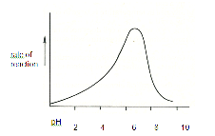
___________________________________________________________________________________________________________________________________________________________________________________________________
- The graph shows the rate of an enzyme reaction at different levels of acidity or alkalinity (pH). From the graph, what is the optimum pH for this enzyme?
(a) pH 2 (c) pH 10

(b) pH 7 (d) none of these.

- A protein-digesting enzyme when mixed with starch solution would:
  - Have no action
  - Produce amino acids
  - Produce glucose
  - Digest starch
Explain your answer.
____________________________________________________________________________________________________________________________________________________________________________________
- What is the induced fit model for enzyme action? Produce a diagram to assist.
________________________________________________________________________________________________________________________________________________________________________________________________________________________________________________________

- Enzyme inhibitors reduce or eliminate the functionality of the active site and therefore limit the effect of enzymes. Find and then compare the 2 types of inhibitors. Structure your answer how you choose.

Biological Molecules- Key terms
Define these key terms:
Key term | Definition
Polarised
Glycosidic Bond
Water potential
Hydrophilic head
Hydrophobic tail
Saturated molecule
Unsaturated molecule
Peptide bond
R group
Carboxyl group
Amino group
Disulfide bridge
Activation energy
Substrate
Enzyme-substrate complex
Rate of reaction

Data and How Science Works
In each of the situations below give the independent, dependent and a control variable.
- An ecologist wanted to study how light levels affected the growth of daisies in a field.
  - Independent:
  - Dependent
  - Control
- Antibiotic resistance is a huge concern to microbiologists. One such scientist has done an experiment to monitor the growth of MRSA when treated with various virus strains.
  - Independent
  - Dependent
  - Control
- A doctor is worried her patient has variable blood sugar levels and is struggling to control his diabetes. She orders bloods tests to monitor his blood sugar at various times of the day.
  - Independent
  - Dependent
  - Control
- Botanists are concerned that oak trees appear to be photosynthesising at a reduced rate due to some limiting factor. They theorise it could be due to the amount of light absorbed through a falling chlorophyll quantity. As a focus, they study concentration of chlorophyll and measure the amount of absorption in a colourimeter.
  - Independent
  - Dependent
  - Control

Below describe the shapes of each graph using the correct terminology:
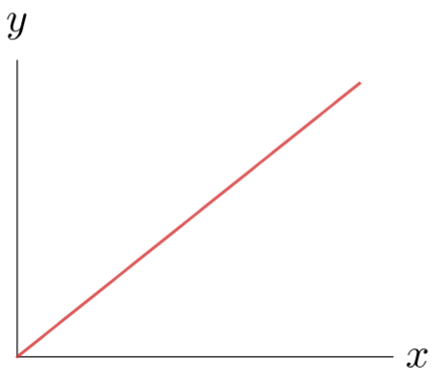
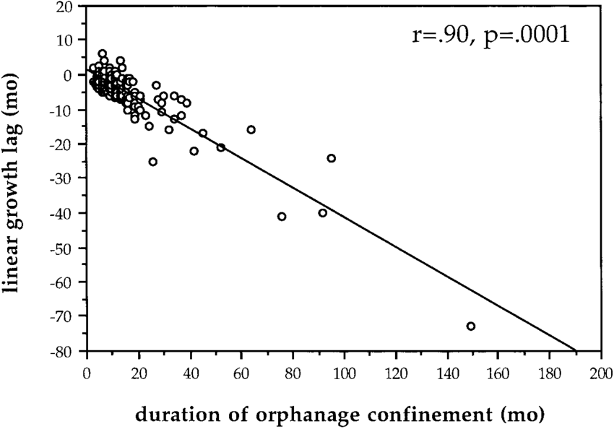

______________________________________________________________________________________________________________________________________________________________________________________________________________________________
______________________________________________________________________________________________________________________________________________________________________________________________________________________________

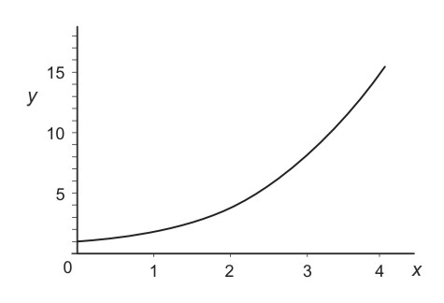
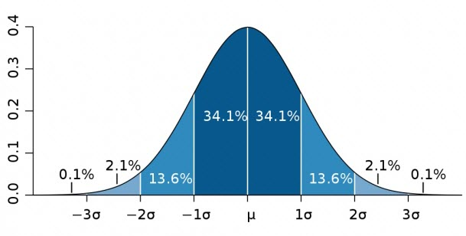

______________________________________________________________________________________________________________________________________________________________________________________________________________________________
______________________________________________________________________________________________________________________________________________________________________________________________________________________________

Define these key terms:
Precise _______________________________________________________________
Accurate _______________________________________________________________
Reliable _______________________________________________________________
Repeatable
_______________________________________________________________
Valid
_______________________________________________________________
Correlation
_______________________________________________________________
Anomalous
_______________________________________________________________

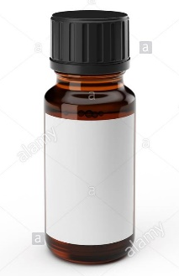
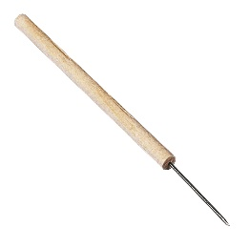
A student wanted to investigate the rate of mitosis in a root tip. She took various samples and used a microscope to count each cell undergoing one of the 5 stages of mitosis. Describe the method she would use to get valid results. Some equipment has been suggested.
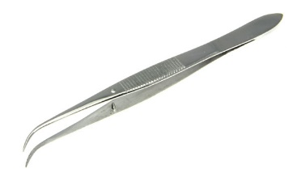

________________________________________________________________________________________________________________________________________________________________________________________________________________________________________________________________________________________________________________________________________________________________________________________________________________________________________________________________________________________________________________________________________________________________________________________________________________________________________________________________________________________________________________________________________________________________________________________________________________________________________________

Use the space provided below to write a risk assessment for the practical you have described above

Research Project
Hopefully, you have chosen biology because you are passionate about the subject and care about the global biological challenges facing organisms and the impact we can make as scientists on shaping our future plant.
As biology is such a diverse subject, ranging from the microscopic to the whole planet, we would like you to research and develop a project around something you have a personal interest in.
This is an opportunity to decide what you learn and to become an aspiring expert in a field of your choice.
If you are struggling for ideas here a few prompts:
- Think about what made you choose A-level biology.
- What did you enjoy learning most during GCSE biology?
- Has there been anything in the news/media that you were fascinated by?
- Are there any issues either globally or locally that you want to know more about?
- Are there medical conditions that are personal to you or that you’ve heard of and want to know more about?
For this project you will need to:
- Produce an infographic poster
- Include any relevant diagrams or data.
- Be prepared to bring this with you when you begin the course so we can share all the interesting things you have learned about your chosen topic.

Alternative optional extras:
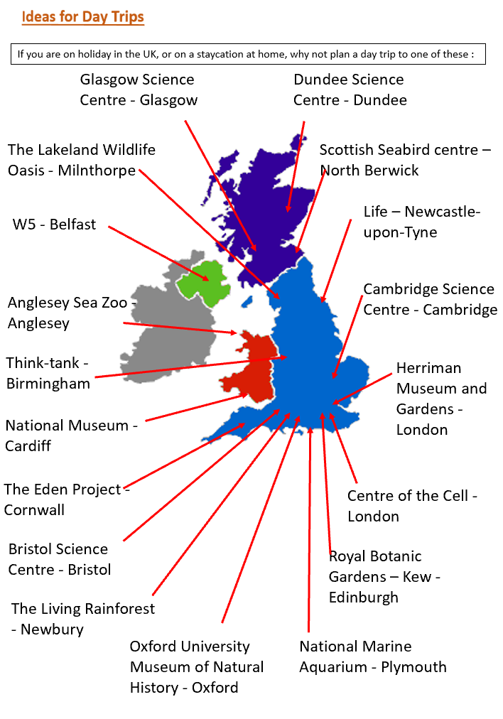

Why not try watching some scientific talks?


We would like to thank you for opting to take A-level biology and we are extremely proud to support you in your continued education here at Kingsthorpe College. Please enjoy your summer and see you in September.
