YEAR 11 – 12 TRANSITION PROJECT

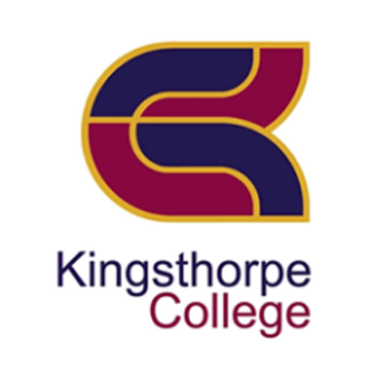

- Pearson BTEC Level 3 NATIONAL EXTENDED CERTIFICATE IN BUSINESS (single award)

Course Overview
Exam Board: Edexcel
Duration: 2 Years
The Extended Certificate (single award) in BTEC Level 3 Business is for pupils who are interested in learning about the business sector alongside other fields of study. This exciting and challenging course covers key knowledge and practical skills required in the world of Business.
How will I be assessed?
As this is a BTEC course, students will be continually assessed throughout the two years.
- For the single award two of the units will be internally assessed and the remaining two units will be externally assessed. Students will have the option to re-sit both externally assessed units if required.
Unit 1: Exploring Business An overview of business success, how businesses are organised, how they communicate, the characteristics of the environment in which they operate. (Internally Assessed)
Unit 2: Developing a Marketing Campaign This unit will give you an insight into how important marketing is to business. It will enable you to make an informed choice as to whether you want to specialise in marketing in employment, training or higher education. (Externally Assessed)
Unit 3: Personal and Business Finance This unit will provide a foundation for a number of other finance and business units and will help you to analyse profitability, liquidity and business efficiency. (Externally Assessed)
Unit 8: Recruitment and Selection You will learn that successful recruitment is key to maintaining the success of a business, as people (employees) are often considered to be the most valued resource or asset. This unit gives you the opportunity, through role play, to take part in selection interviews either face to face or virtually. You will need to be organised and prepared so that you can demonstrate your communication skills in this work-related competence. (Internally Assessed)
- Next steps progression on completion of the 2-year post-16 course:
This Level 3 BTEC qualification offers an introduction to the business sector through applied and practical hands-on learning. For learners whom an element of business would be complementary, the qualification supports progression to University or Higher Education or an Apprenticeship or directly to full time employment, when taken as part of a programme of study that includes other vocational or general qualifications.

Transition pack Information
This pack contains a programme of activities and resources to prepare you to start the BTEC Level 3 National Extended Certificate or BTEC Level 3 National Diploma in Business in September 2023. It is aimed to be used throughout the remainder of the summer term (June-July) and over the summer holidays to ensure you are ready to start your course in September and can submit your first piece of work for assessment when you return to Year 12.

The range of activities will provide you with a good starting point for your Year 12 studies. Whether you have studied the subject at KS4 or have a general knowledge of the world of business, the following activities based on one of the most successful profit-making businesses in the world today, will help give you:

- a realistic expectation of the subject and the requirements of a coursework unit
- independent research skills
- an appreciation of the fact that there will be lots of new content for you to learn
- an ability to contribute in lessons with real world examples

Overview of Unit 1
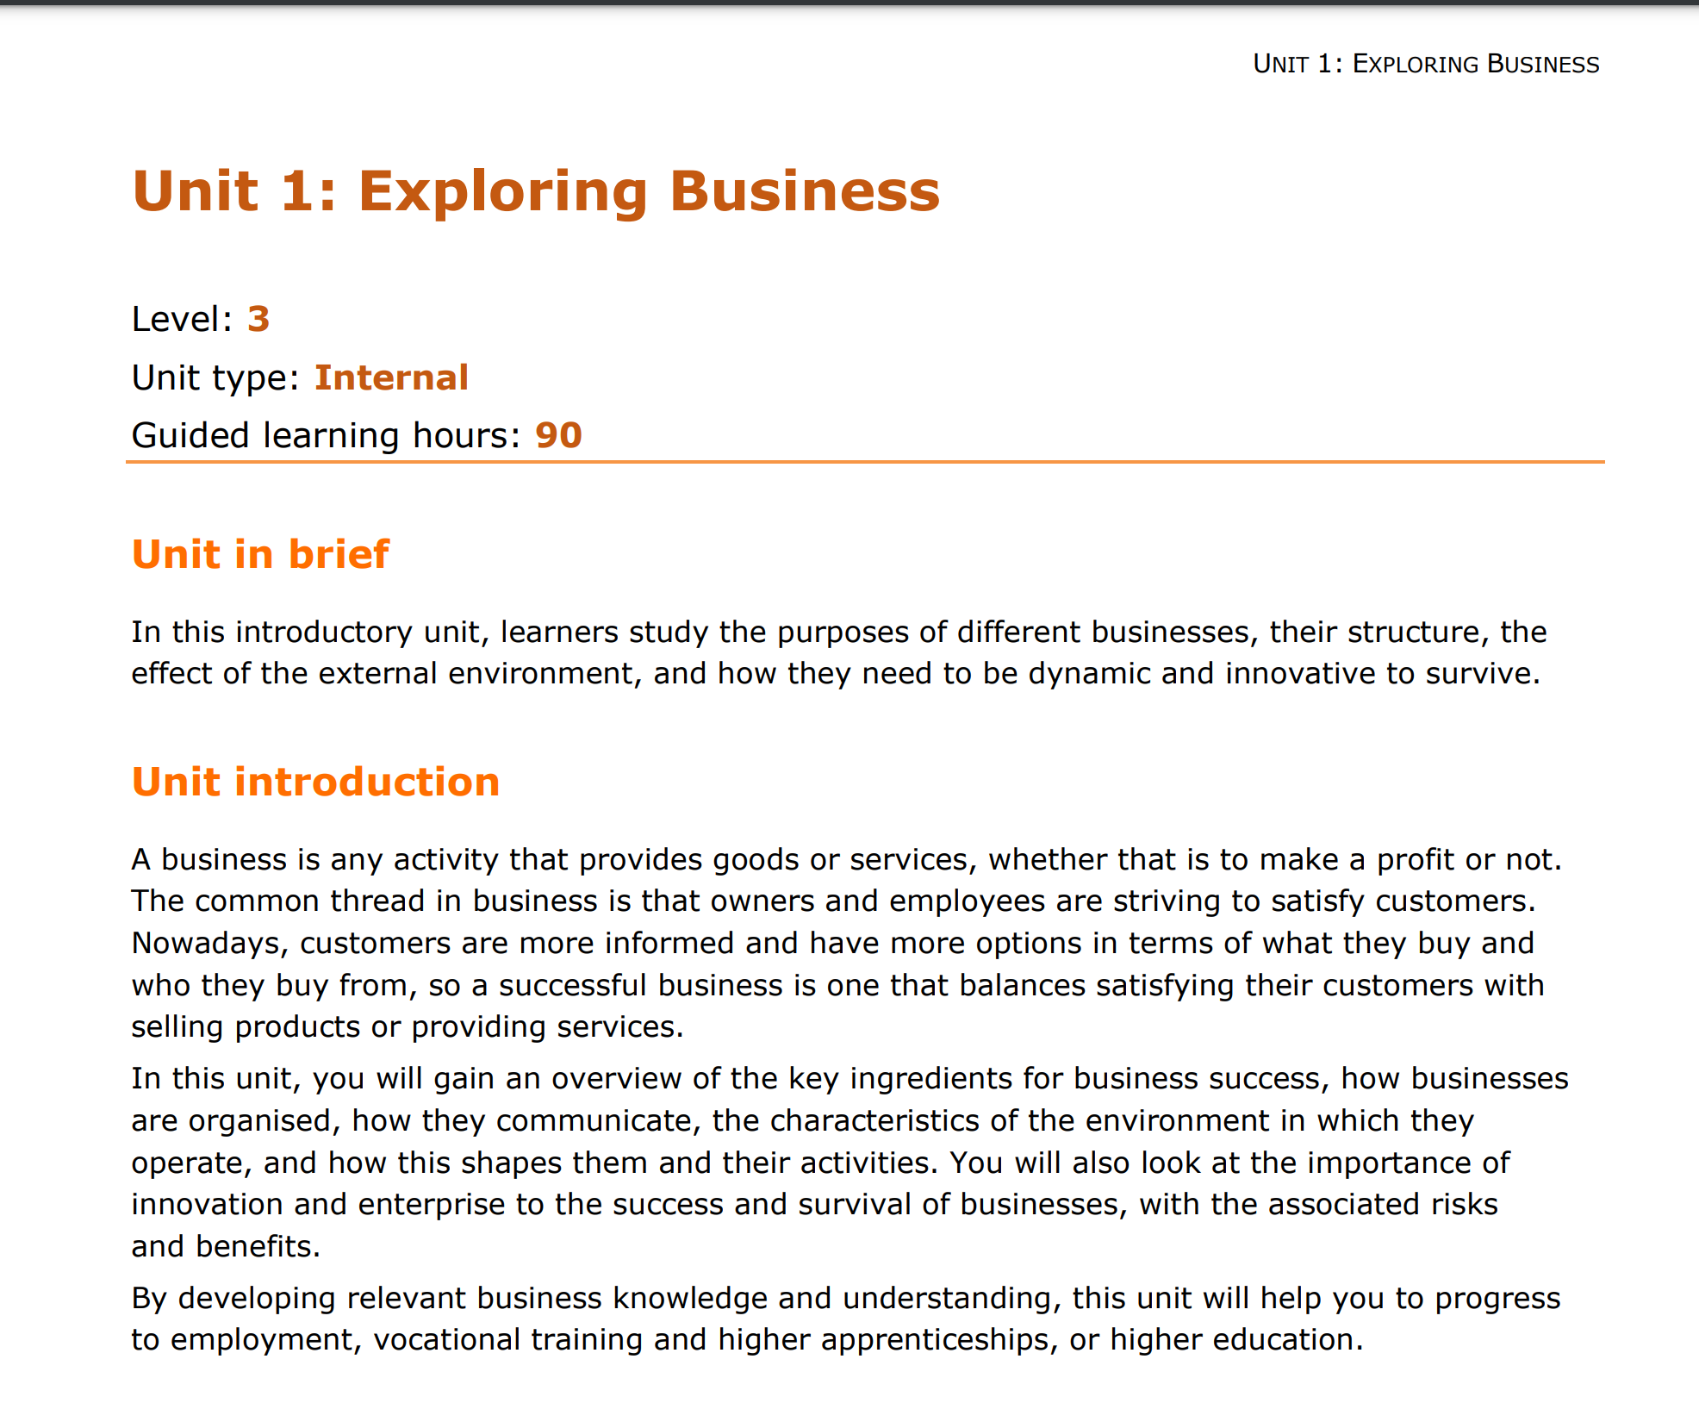
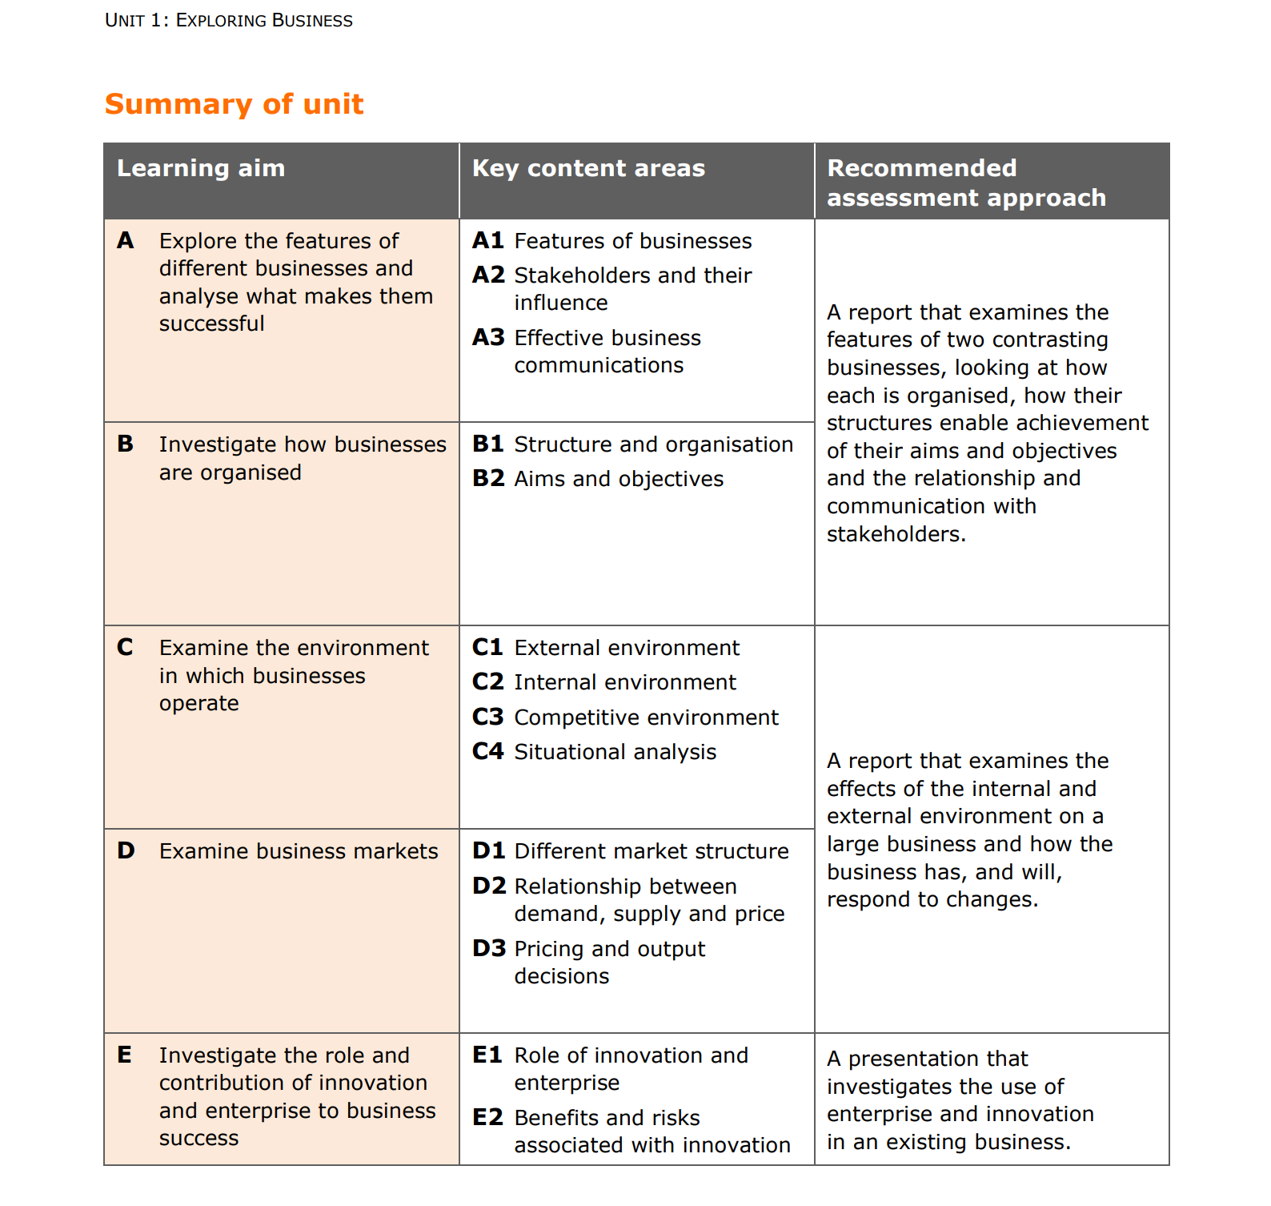

Transition work part 1:
Key Vocabulary – research into some key business terminology
During this Unit 1 Exploring business coursework unit and transition project, you will be introduced to some new or key business specific vocabulary that will be used throughout your studies in your business course. For each key term write up a definition, in your own words and give at least one examples, where appropriate to relate to your understanding of how it relates to your chosen for-profit making business (in Transition work part 2):

Key Terms | Definition
Industry sector
Scope of business activities

Market share

Competitive advantage
Hybrid business model
Stakeholders
Branding
Innovation
Legal structure/ business ownership

Limited liability
Unlimited liability
Private limited company
Public limited company
CSR (Corporate social responsibility)

Corporate Culture

SMART Aims and
Objectives

Situational Analysis

PESTLE
SWOT
Porters Five Forces

Transition work part 2:
Researching the features of two contrasting businesses.
Assignment title - Learning Aim A: Features contributing to the success of contrasting businesses
P1 – explain the features of TWO chosen contrasting businesses: for-profit and non-profit
Please ensure you present your assignment as a word-processed document and use the numbered bullet pointed sub-headings I have provided below to structure your document and report about the different features of your two chosen contrasting businesses.
Please also include your first and surname in the header of the document.
Please aim for minimum 2 pages of A4 for this transition work and use minimum font size 12.

For-Profit please choose ONE business from the list below to research:
- Tesla
- Tesco
- Aldi
- Amazon
- Costa Coffee
- Starbucks
- Nike
- Sony
- McDonald’s
Exploring the features of your for-profit business:
1. Introduce your chosen for-profit business briefly and also add their logo to your intro
i.e. What is the name of your profit-making making business?
When was it established/set up e.g. what year? who created or founded the profit-making business?
2. Purpose of the business
Does it supply goods/products? a service? or both i.e. do they have a hybrid approach?

3. Size of the business
How many employees do they currently have?
How many stores do they have ?

4. Scope of the business
Is it local, national or an international business?
Explain and (provide evidence) to support how you know this? (screenshot from a website etc)

5. Business sector of operation
Primary, secondary, tertiary or quaternary sector?
Do they operate in more than one sector? Why? How do you know?
Explain and justify your answer.

6. Ownership of the business (use these two websites to assist you: https://www.bbc.co.uk/bitesize/guides/zjfxvk7/revision/4
https://www.bbc.co.uk/bitesize/guides/zmdhhbk/revision/5 )
Is it public or privately owned? If it is under private ownership, what is the business structure? Is it a sole trader, partnership, cooperative, PLC or LTD? Is there a CEO or President of the business?

7. What liability does the business have?
Does it have unlimited liability, limited liability or is it limited by guarantee?
What does this mean for the business?
Explain the implications of your answer and what the liability of the company means in terms of responsibility and risk for the business owners and/or shareholders.
_______________________________________________________________
Non-Profit please choose ONE business from the list below to research:
- Oxfam
- Cancer Research UK
- Water Aid
- British Heart Foundation
- British Red Cross
- Mind
Exploring the features of your non-profit business:
6. Introduce your chosen non-profit business briefly and also add their logo to your intro
i.e. What is the name of your non-profit-making business?
When was it established/set up e.g. what year? who created or founded the non-profit business?
7. Purpose of the business
Does it supply goods/products? Or a service? Or both?

8. Size of the business
How many employees do they currently have?
How many volunteers do they currently have?
How many stores do they have (where applicable)?

9. Scope of the business
Is it local, national or an international business?
Explain and (provide evidence) to support how you know this? (screenshot from a website etc)

10. Business sector of operation
Primary, secondary, tertiary or quaternary sector?
Do they operate in more than one sector? Why? How do you know?
Research what the third sector is and how this relates to your chosen non-profit business (use this website to help you: https://www.bbc.co.uk/bitesize/guides/zjfxvk7/revision/8 )

11. Ownership of the business
Is it public or privately owned? If it is under private ownership, what is the business structure? Is there a CEO or President of the business? What about board of trustees?
Use this website to help you: https://www.ncvo.org.uk/help-and-guidance/setting-up/understanding-charity-status-and-registration/#/ and also research the leadership of your chosen charity which you should be able to find on their actual website e.g.
https://www.oxfam.org.uk/about-us/oxfams-ceo-directors-and-trustees/ and https://www.cancerresearchuk.org/about-us/our-organisation

12. What liability does the business have?
What does it mean for a non-profit’s liability to be “limited by guarantee”? What does this mean for the business/charity? Use these two website to assist you:
https://www.gov.uk/setting-up-charity/structures
https://www.lawbite.co.uk/resources/blog/what-is-a-company-limited-by-guarantee
Explain the implications of your answer and what the liability of the non-profit means in terms of responsibility for any debts or financial mistakes made by the charitable organisation.

Transition work part 1 and 2 deadline for submission:
Friday 6th September 2024
Contact information:
Any questions about the post-16 Level 3 Business transition work please contact:
Mrs Chukwudi, Head of Business on: julie.chukwudi@kingsthorpecollege.org.uk
For any technical issues please contact: Home.Learning@kingsthorpecollege.org.uk

